COMPARATIVE ANALYSIS OF AIR POLLUTION PATTERNS ACROSS INDIAN STATES
24ADI204 - DATA SCIENCE AND VISUALISATION
Submitted by
MOHD SHAFIQUE R B 24BAD074
RESHMA S 24BAD097
SASTHA JEYASRI A 24BAD106
THARUN A 24BAD126
in partial fulfilment for the award of the degree of

BACHELOR OF TECHNOLOGY
IN
ARTIFICIAL INTELLIGENCE AND DATA SCIENCE


KUMARAGURU COLLEGE OF TECHNOLOGY
(An Autonomous Institution affiliated to Anna University, Chennai)
Post Box No: 2034, Coimbatore - 641049

APRIL 2026
BONAFIDE CERTIFICATE

Certified that this project report is the Bonafide COMPARATIVE ANALYSIS OF AIR POLLUTION PATTERNS ACROSS INDIAN STATES work of MOHD SHAFIQUE R B-24BAD074 ,RESHMA S-24BAD097, SASTHA JEYASRI A-24BAD106, THARUN A-24BAD126 who carried out project work under my supervision.

SIGNATURE SIGNATURE

Dr. Sudharson D
HEAD OF THE DEPARTMENT
Department of Artificial Intelligence and Data Science,
Kumaraguru College of Technology, Coimbatore – 641049.
Ms. Rupashini P R
SUPERVISOR
Department of Artificial Intelligence and Data Science,
Kumaraguru College of Technology, Coimbatore – 641049.

The candidates with college register number 24BAD074, 24BAD097, 24BAD106, 24BAD126 were examined in the Project Viva-Voce examination held on
……………...

Internal Examiner External Examiner

DECLARATION
I affirm that the project work titled COMPARATIVE ANALYSIS OF AIR POLLUTION PATTERNS ACROSS INDIAN STATES
being submitted in partial fulfillment for the award of B. TECH Artificial Intelligence and Data Science is the original work carried out by us. It has not formed the part of any other project work submitted for the award of any degree or diploma, either in this or any other University.
MOHD SHAFIQUE R B 24BAD074

RESHMA S 24BAD097

SASTHA JEYASRI A-24BAD106

THARUN A - 24BAD126

I certify that the declaration made above by the candidates is true.
Mrs. Rupashini P R
Assistant Professor,
Department of Artificial Intelligence and Data Science,
Kumaraguru College of Technology,
Coimbatore - 64104

EXECUTIVE SUMMARY:
Air pollution is now one of India's biggest environmental problems because it directly affects people's health, the weather, and their quality of life. To understand how pollution works and make better decisions about the environment, it's important to keep an eye on air quality in different areas.

This project is about comparing the air quality in different states of India by looking at data on air pollutants from several cities. The dataset employed in this study comprises daily air quality measurements, including PM2.5, PM10, NO2, SO2, CO, O3, AQI, and AQI category values. The goal of the project was to clean, preprocess, analyze, and visualize the dataset in a way that made sense so that pollution trends and differences between states could be found.

The workflow included cleaning the data, dealing with missing values, handling outliers, choosing the right features, mapping states from city-level data, exploratory data analysis, correlation analysis, and making dashboards. Power BI was used to make the final dashboard, which lets you see how the AQI compares between states, how pollutants are spread, how AQI categories change over time, and how pollution trends change over time.

The study found that air quality is very different in different states of India and that pollutants like PM2.5 and PM10 are major causes of bad air quality. The project shows how storytelling and data visualization can turn raw environmental data into useful information that can be used to raise awareness and support policies.
TABLE OF CONTENTS:  S. No. | Chapters / Sections |  |  | Page No.
1 | Chapter 1: Introduction
 | 1.1 Background of the Problem |  |  | 9
 | 1.2 Importance of the Study |  |  | 9
 | 1.3 Objectives of the Project |  |  | 9
 | 1.4 Scope of the Project |  |  | 9
2 | Chapter 2: Dataset Description
 | 2.1 Source of Dataset |  |  | 9
 | 2.2 Dataset Size |  |  | 9
 | 2.3 Description of Features |  |  | 10
 | 2.4 Initial Data Issues |  |  | 10
3 | Chapter 3: Data Preprocessing and Cleaning
 | 3.1 Data Loading and Inspection |  |  | 11
 | 3.2 Handling Missing Values |  |  | 11
 | 3.3 Outlier Detection and Treatment |  |  | 12
 | 3.4 Data Quality Report Summary |  |  | 12
4 | Chapter 4: Exploratory Data Analysis (EDA)
 | 4.1 Univariate Analysis |  |  | 12
 | 4.2 Bivariate Analysis |  |  | 12
 | 4.3 Key Observations and Patterns |  |  | 13
5 | Chapter 5: Data Transformation and Feature Engineering
 | 5.1 Feature Scaling |  |  | 20
 | 5.2 Encoding Techniques |  |  | 20
 | 5.3 Feature Engineering |  |  | 20
 | 5.4 Before vs After Comparison |  |  | 21
6 | Chapter 6: Advanced Analysis
 | 6.1 Correlation Analysis |  |  | 21
 | 6.2 Feature Selection |  |  | 21
 | 6.3 Principal Component Analysis (PCA) |  |  | 21
 | 6.4 Explained Variance and Interpretation |  |  | 24
7 | Chapter 7: Visualization and Dashboard
 | 7.1 Tools Used |  |  | 25
 | 7.2 Types of Visualizations Used |  |  | 25
 | 7.3 Dashboard Design and Layout |  |  | 26
 | 7.4 Dashboard Explanation |  |  | 26
 | 7.5 Dashboard Screenshots |  |  | 27
8 | Chapter 8: Insights and Storytelling
 | 8.1 Key Findings |  |  | 28
 | 8.2 Patterns and Trends Identified |  |  | 28
 | 8.3 Social and Analytical Insights |  |  | 28
 | 8.4 Decision-Making Based on Results |  |  | 28
9 | Chapter 9: Conclusion
 | 9.1 Summary of the Project |  |  | 29
 | 9.2 Outcomes Achieved |  |  | 29
 | 9.3 Limitations |  |  | 29
 | 9.4 Future Scope |  |  | 29
10 | Chapter 10: References |  |  | 30
 | Appendix |  |  | 31
Abbreviation | Full Form
PM2.5 | Particulate Matter (diameter ≤ 2.5 micrometers)
PM10 | Particulate Matter (diameter ≤ 10 micrometers)
NO₂ | Nitrogen Dioxide
SO₂ | Sulfur Dioxide
CO | Carbon Monoxide
O₃ | Ozone
AQI | Air Quality Index
EDA | Exploratory Data Analysis
PCA | Principal Component Analysis
IQR | Interquartile Range
CPCB | Central Pollution Control Board

Figure No. | Title
Figure 1 | Distribution of PM2.5 Levels
Figure 2 | Distribution of PM10 Levels
Figure 3 | Distribution of NO₂ Levels
Figure 4 | Distribution of SO₂ Levels
Figure 5 | Distribution of CO Levels
Figure 6 | Distribution of O₃ Levels
Figure 7 | Correlation Heatmap of Pollutants
Figure 8 | Scatter Plot of PM2.5 vs AQI
Figure 9 | Scatter Plot of PM10 vs AQI
Figure 10 | Relationship between NO₂ and AQI
Figure 11 | State-wise Average AQI
Figure 12 | State-wise PM2.5 Comparison
Figure 13 | State-wise PM10 Comparison
Figure 14 | Top 10 Most Polluted States
Figure 15 | Least Polluted States
Figure 16 | AQI Trend Over Time
Figure 17 | PM2.5 Trend Over Time
Figure 18 | Monthly Pollution Trend
Figure 19 | Yearly Pollution Trend
Figure 20 | Dashboard Overview
Figure 21 | KPI Cards for Air Quality Indicators
Figure 22 | State Comparison Bar Chart
Figure 23 | AQI Category Distribution
Figure 24 | Pollution Trend Line Chart
Figure 25 | Geographic Map of Pollution Levels
Figure 26 | Top Polluted States Ranking
Figure 27 | PCA Explained Variance Plot
Figure 28 | PCA Component Visualization
Figure 29 | Feature Importance Analysis
Figure 30 | Final Insights Visualization

CHAPTER 1: INTRODUCTION
1.1 Background
Air pollution has become one of the most severe environmental challenges in India. Rapid industrialization, urbanization, and vehicular emissions have contributed significantly to deteriorating air quality.
1.2 Importance of the Study
Understanding pollution patterns helps in:
- Identifying high-risk cities
- Designing pollution control strategies
- Supporting public health decisions
1.3 Objectives
- Analyse air pollution trends across cities.
- Identify key pollutants influencing the AQI.
- Apply data preprocessing and feature engineering techniques.
- Use PCA for dimensionality reduction.
1.4 Scope
The project focuses on data analysis and pattern identification, not prediction modelling or deployment.

CHAPTER 2: DATASET DESCRIPTION
2.1 Source
- The dataset was obtained from:
- Central Pollution Control Board (CPCB)
- Kaggle Air Quality datasets
2.2 Dataset Size
- Rows: ~29,000+
- Columns: 16+ features

2.3 Features
- City
- Date
- Pollutants: PM2.5, PM10, NO₂, SO₂, CO, O₃, Others
- AQI
- AQI Bucket
2.4 Initial Issues
- Missing values occur because data collection is incomplete or inconsistent.
- Outliers arise from extreme pollution spikes or measurement errors.
- Key pollutants, like PM2.5 and PM10, show skewed distributions that require normalization.
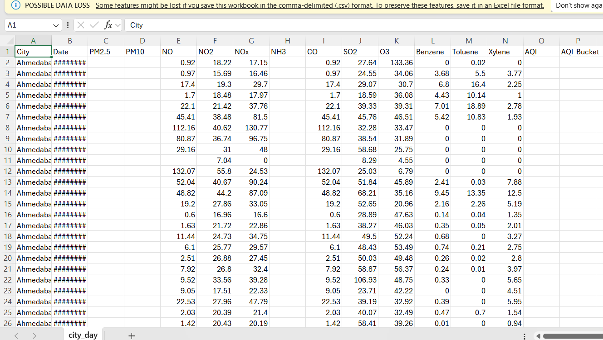
REFERENCE:
(Sharma, 2021)
(Guttikunda S. K., 2013)
(Zhou, 2025)
CHAPTER 3: DATA PREPROCESSING AND CLEANING
3.1 Data Loading
I used Pandas to load the dataset. I checked the shape, null values, and data types.
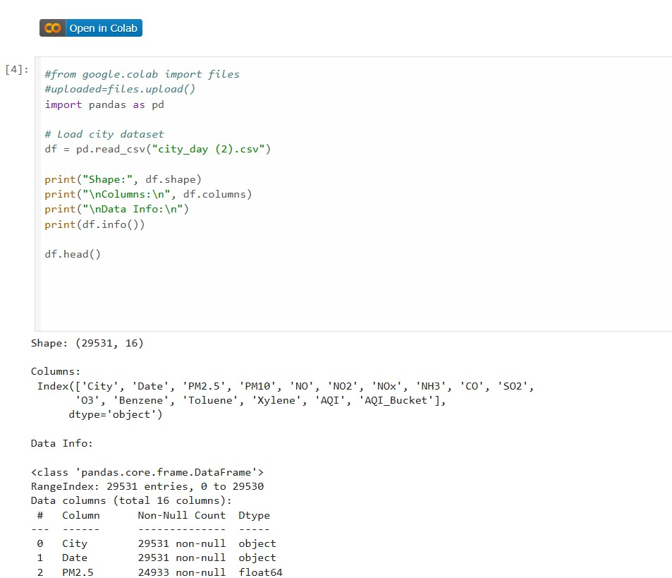
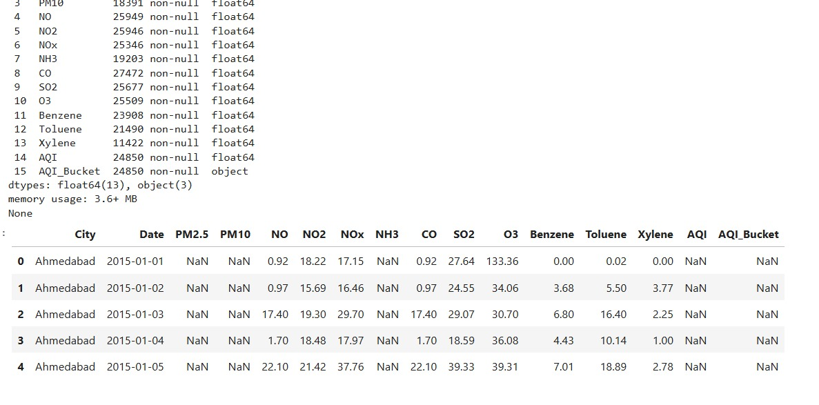
3.2 MISSING VALUE HANDLING:
- Numerical → Median Categorical → Mode Justification: The median is strong against outliers and provides a stable central tendency.
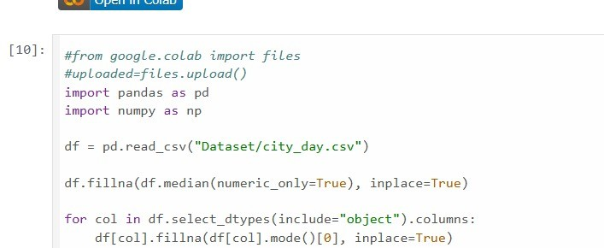
3.3 OUTLIER DETECTION:
- Outlier Detection I used the IQR method.
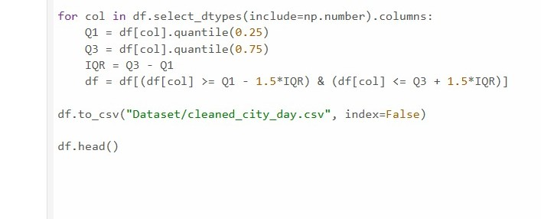
3.4 DATA QUALITY SUMMARY:
Data Quality Summary I reduced noise. I improved consistency. I prepared the dataset for analysis.
CHAPTER 4 : EXPLORATARY DATA ANALYSIS
4.1 Univariate Analysis Distribution:
This plots showed skewness in PM2.5 and PM10. AQI distribution revealed high pollution spikes.
4.2 Bivariate Analysis:
- There is a strong relationship between AQI and PM2.5.
- There is a moderate relationship with NO₂ and CO.
4.3 Key Observations:
Particulate matter is the dominant pollutant. Some cities consistently show higher pollution.
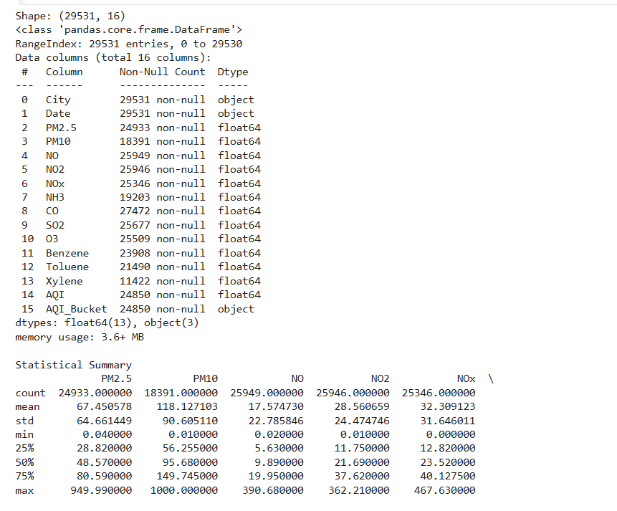
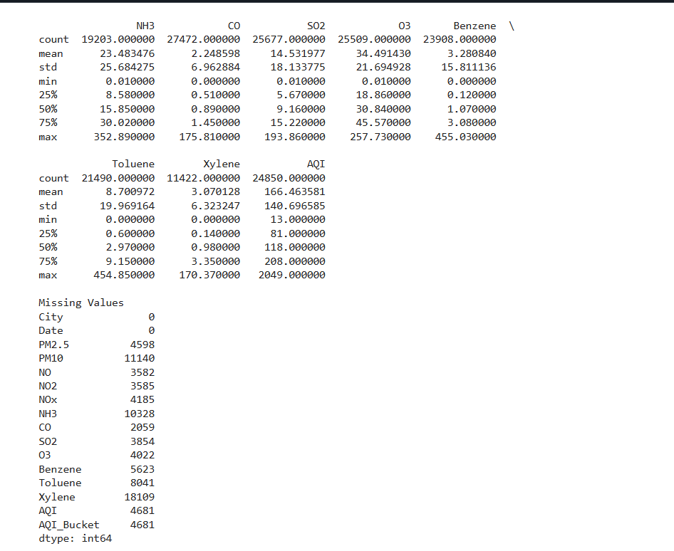
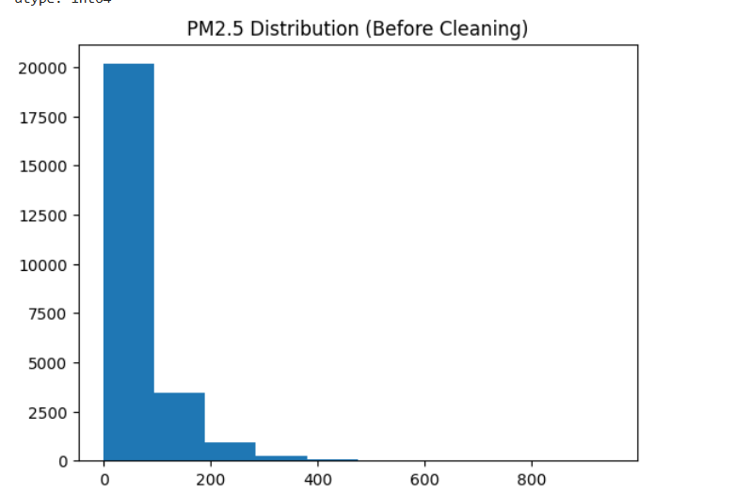
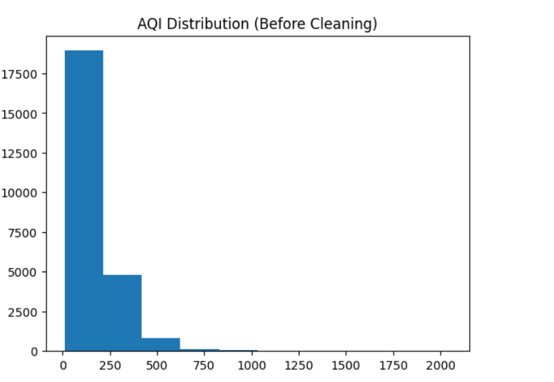
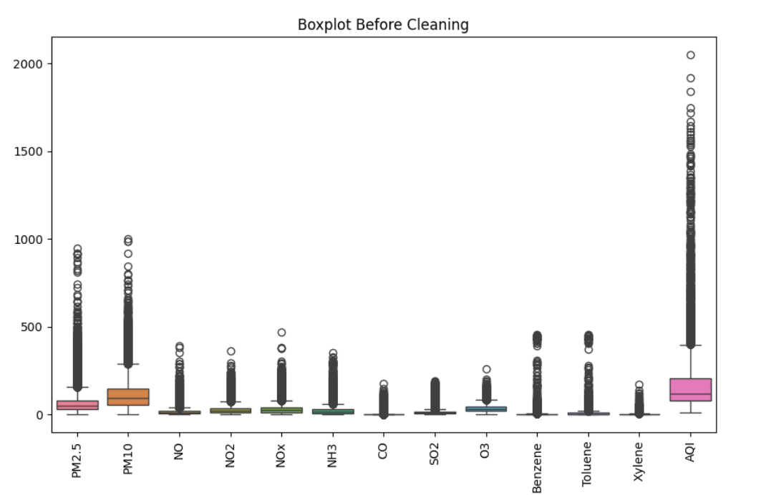
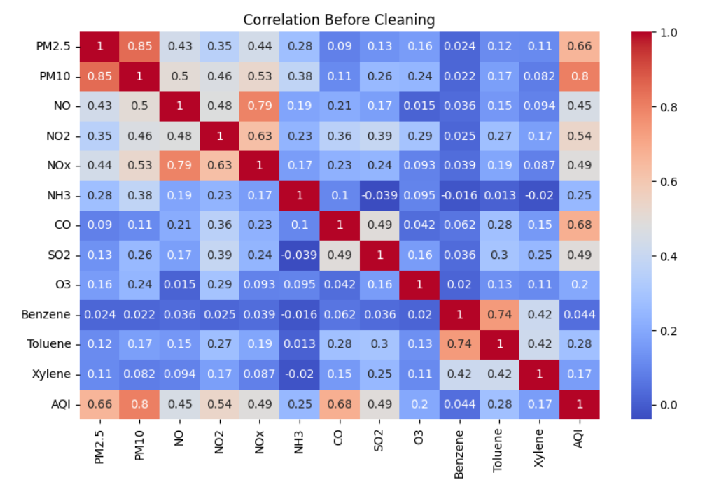
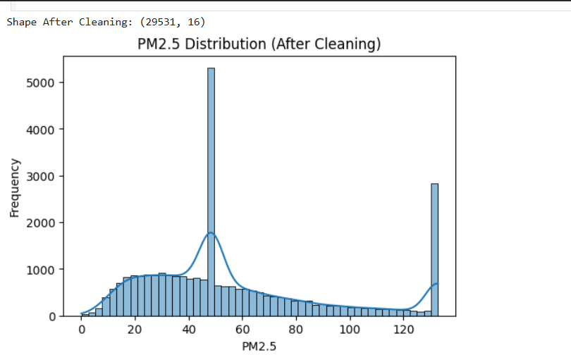
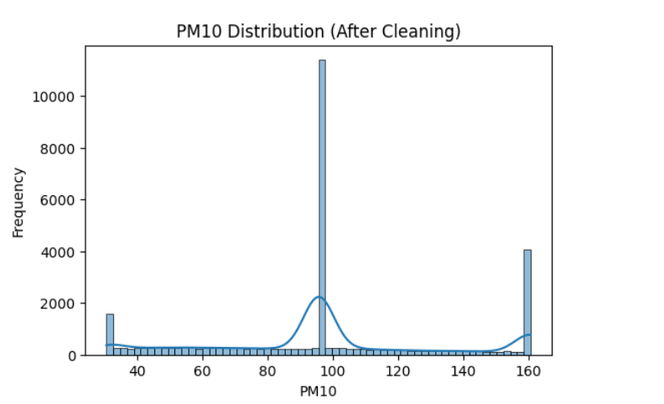
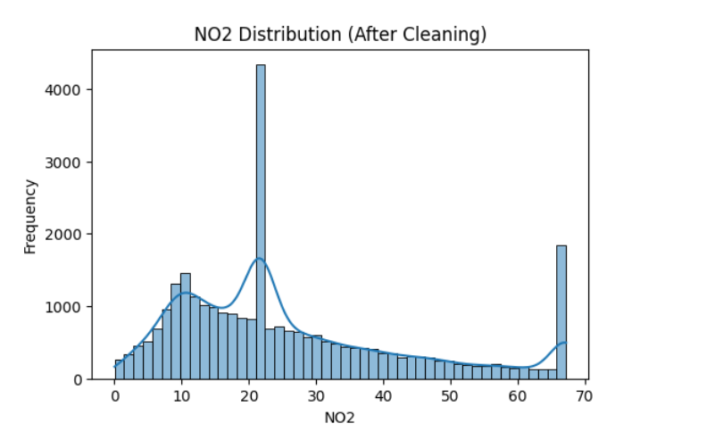
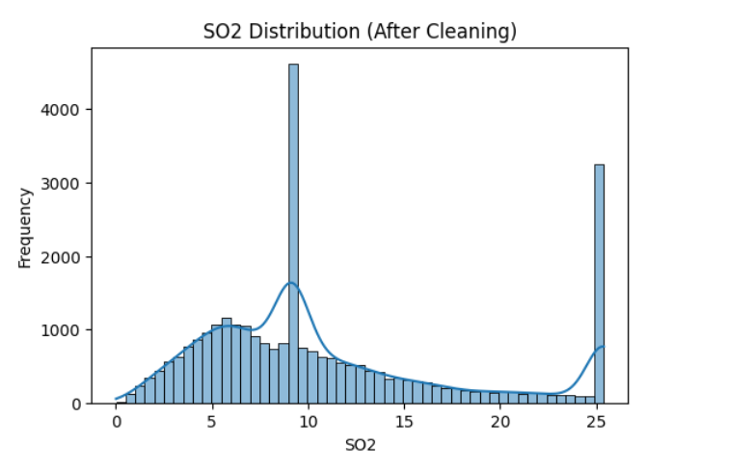
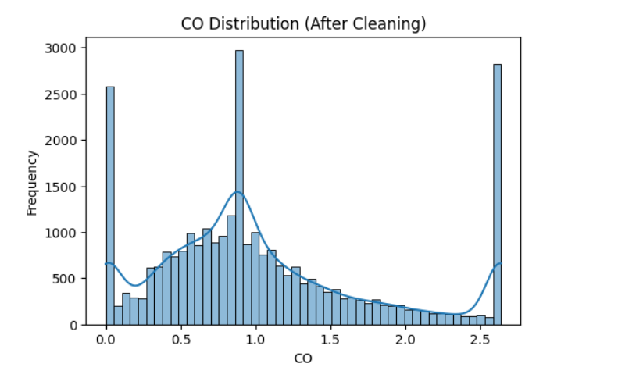
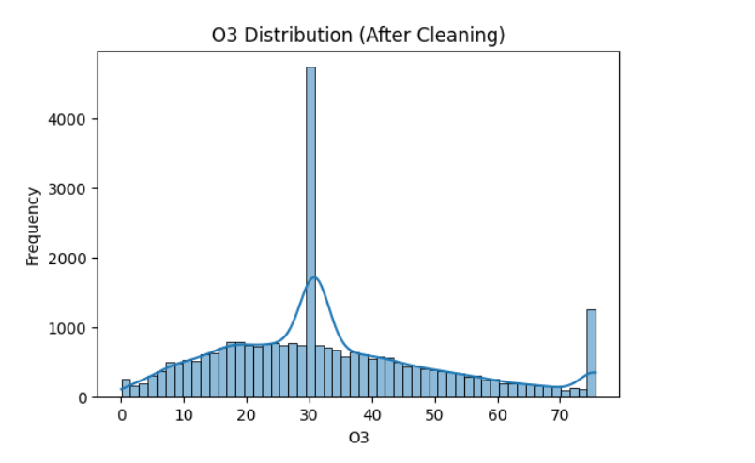
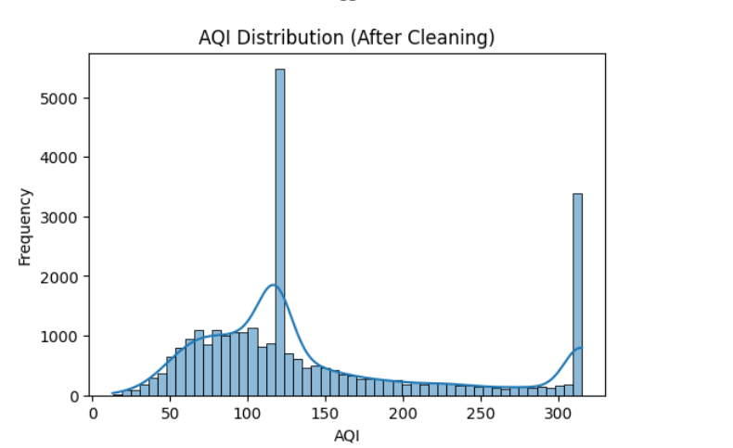
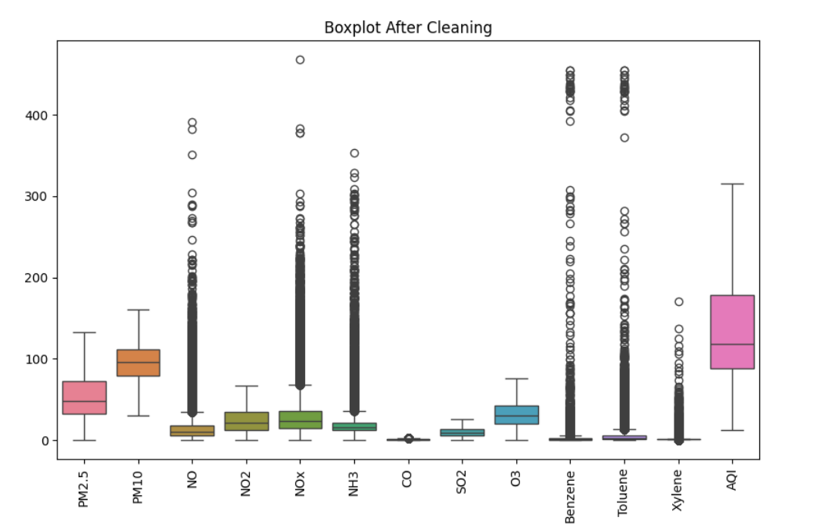
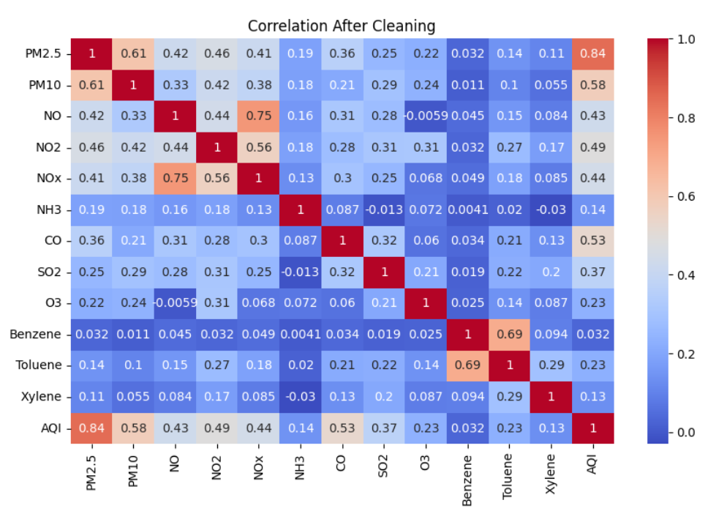
REFERENCE:
(Gil-Alana, 2025)
CHAPTER 5: DATA TRANSFORMATION AND FEATURE ENGINEERING
5.1 Feature Scaling:
Normalized data through the use of standardization Ensured equal contribution of all features.
5.2 Encoding:
- Label encoding was used to convert the AQI bucket.
- Facilitated categorical data's numerical processing.
5.3 Handling Skewness:
Used log transformation to smooth out the skewness Improved distribution for better analysis.
5.4 Before Vs After:
Differences reduced by variance Improved feature comparability.
CHAPTER 6: ADVANCED ANALYSIS
6.1 Correlation Analysis:
There is a strong positive correlation between: AQI & PM2.5 and AQI & PM10.
6.2 Feature Selection:
Selected features:
- PM2.5
- PM10
- NO₂
- SO₂
- CO
- O₃
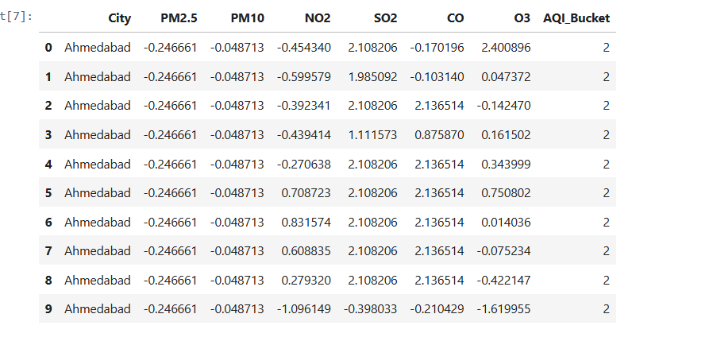
6.3 Principal Component Analysis:
- The dimensionality-reduction method known as Principal Component Analysis (PCA) was looked into for the purpose of locating the underlying patterns of pollutants.
- However, for the final dashboard and state comparison analysis, the original pollutant features were retained to preserve interpretability and support direct comparison of pollutant levels across states.
- This decision was made because the project's goals were to visualize pollutant-specific insights and reduce dimensionality at the same time
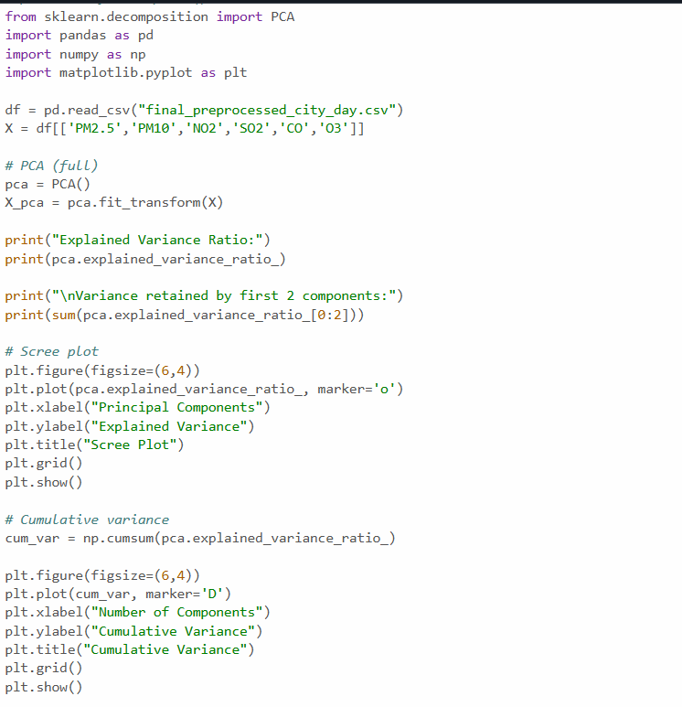
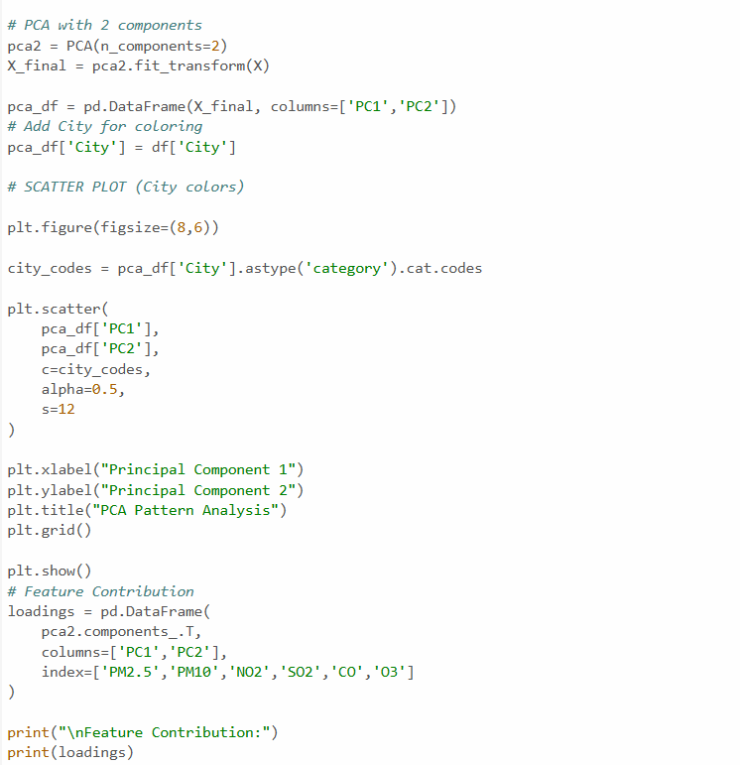
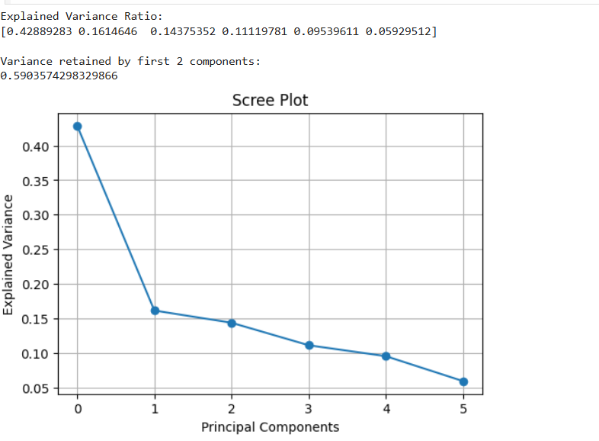
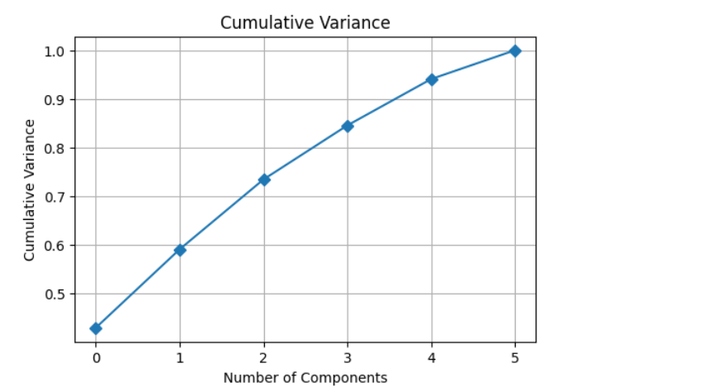
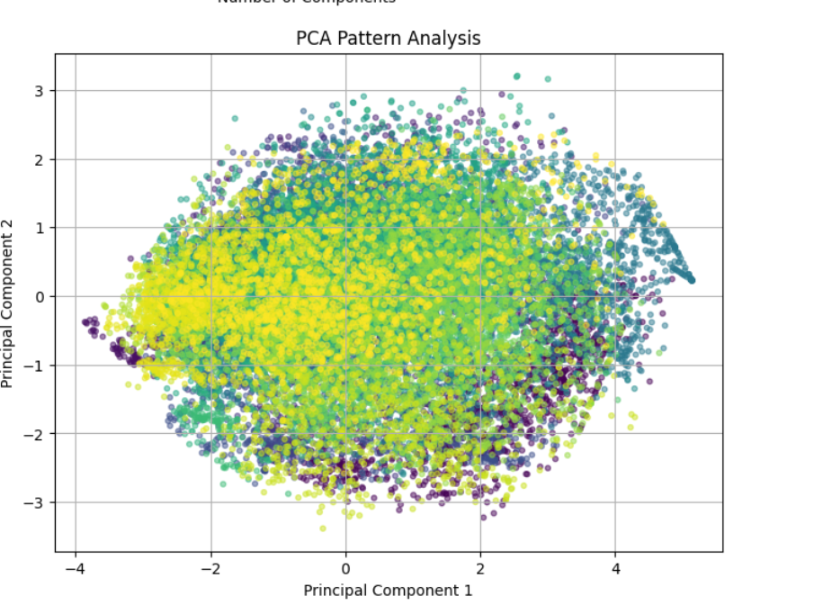
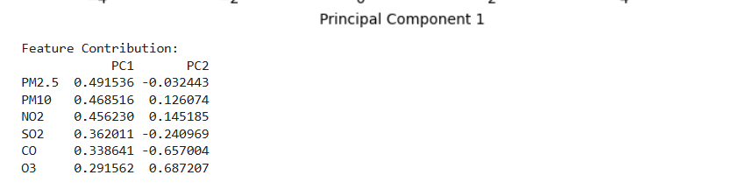
6.4 Explained Variance
- Explained variance represents the amount of information retained by each principal component after applying Principal Component Analysis (PCA). It aids in comprehending the proportion of the total variability in the data that is captured by each component. PCA was used in this project to keep as much information as possible while reducing the dataset's dimensionality. The explained variance ratio indicates the contribution of each principal component to the total variance in the data.
- The majority of the variance was captured by the first few principal components, indicating that fewer dimensions are required to represent the majority of important information. The dataset is simplified as a result of this without significant information loss.
REFERENCE:
(Sharma, 2021)
(Du, 2018)

CHAPTER 7: VISUALIZATION AND DASHBOARD
7.1 Tools Used
- Matplotlib
- Seaborn
- Plotly (optional)

7.2 Visualizations
- Distribution plots
- Boxplots
- Correlation heatmap
- PCA scatter plot
- AQI trend
7.3 Dashboard Explanation

The final dashboard was developed in Power BI to provide an interactive and comparative view of air quality across Indian states. The dashboard was designed using a storytelling approach consisting of overview, comparison, pollutant-level detail, and trend analysis.

The main visual compares states based on AQI, while additional visuals provide pollutant breakdown, AQI category distribution, top polluted states, and time-based pollution trends. Interactive filters were included to improve user
exploration and analysis.

7.4 Dashboard Components

- KPI Cards

- Show average AQI, PM2.5, PM10, and NO2

- State AQI Comparison

- Compares pollution levels across states

- AQI Category Distribution

- Shows pollution severity using AQI_Bucket

- Pollutant Breakdown

- Displays contribution of major pollutants

- Trend Analysis

- Shows AQI or pollutant changes over time

- Ranking Chart

- Highlights most polluted states

7.5 Dashboard Screenshots

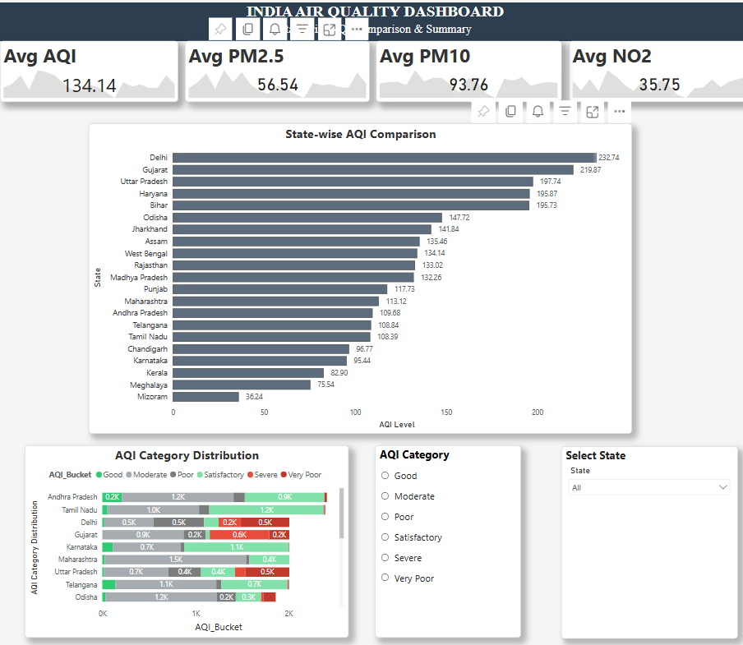
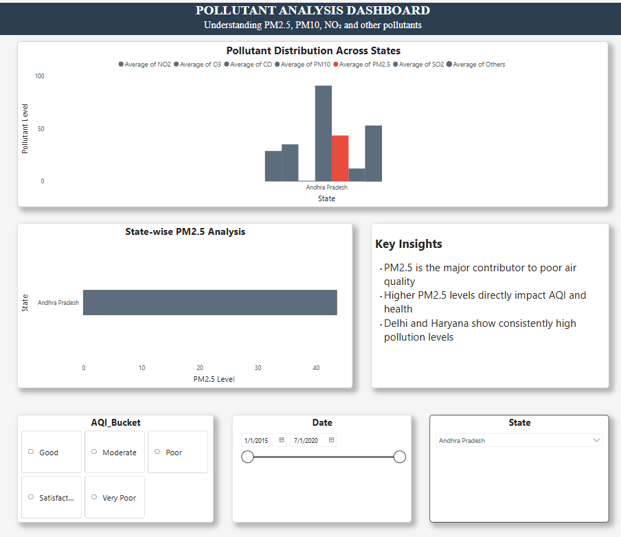
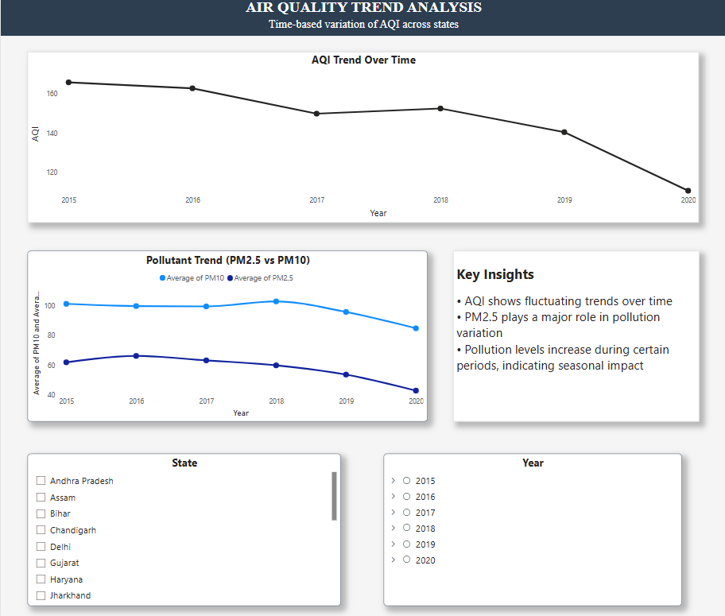
CHAPTER 8: INSIGHTS AND STORYTELLING
8.1 Key findings
- State-by-state comparisons of overall air quality were evident.
- Poor AQI was primarily attributed to PM2.5 and PM10.
- Some areas remained in the moderate or poor AQI categories consistently.
- Pollution levels changed over time and across locations
8.2 Patterns
- Particulate matter had a greater impact than some gases.
- The severity of the pollution was not evenly distributed.
- Trends in the AQI indicated variation in regional pollution
8.3 Business and Social Insights
- Environmental awareness, pollution monitoring, and region-specific intervention planning can all benefit from this project's findings.
- Comparing air quality at the state level can help pinpoint problem areas and target pollution control efforts more effectively.
8.4 Decision making
- Helps by Identifying highly polluted states
- Tracking pollutant trends over time, highlighting important pollutants that affect AQI
- Contributing to efforts to raise awareness and plan.
REFERENCE:
(Zhou, 2025)

CHAPTER 9: CONCLUSION
9.1 Summary of the Project
- This project successfully analysed and visualized air quality patterns across Indian states using data science and dashboarding techniques.
- The workflow included data cleaning, preprocessing, exploratory analysis, feature refinement, and interactive dashboard creation.
- The final dashboard made complex environmental data understandable and useful for making decisions. In general, the project demonstrates how analytical tools can support awareness, monitoring, and informed action as well as the significance of data visualization in environmental analysis.
9.2 Outcomes / Key Results
- States' air pollution levels varied significantly, according to the analysis. Certain regions consistently exhibited higher pollution levels, particularly in terms of PM2.5 and AQI.
- Key pollutants had strong connections between them, according to the correlation analysis. The results of the PCA indicated that fewer components could capture the majority of the variance in the dataset. The dashboard effectively highlighted patterns of pollution, making it simpler to compare and interpret the data.
9.3 Limitations
- Dataset covers only available recorded cities
- The availability of cities affects state representation.
- There were some real-world pollution factors left out.
- Compared to the actual complexity of the environment, the AQI category is simplified.
9.4 Future scope
- Include additional towns and recent years. Include seasonal or weather factors. Integrate forecasting models
- Develop real-time monitoring dashboard
- Expand to district-level or national policy analysis
REFERENCE:
(Singh, 2020)

CHAPTER 10: REFERENCES
1.Sharma, D., & Mauzerall, D. L. (2021)
Analysis of Air Pollution Data in India between 2015 and 2019
https://scholar.google.com/scholar?q=Analysis+of+Air+Pollution+Data+in+India+between+2015+and+2019+Sharma+Mauzerall
2.Balakrishnan, K., et al. (2019)
Impact of air pollution on mortality in India
https://scholar.google.com/scholar?q=Balakrishnan+air+pollution+India+Lancet
3.Guttikunda, S. K., & Goel, R. (2013)
Health impacts of particulate pollution in Delhi
https://scholar.google.com/scholar?q=Guttikunda+Goel+Delhi+air+pollution
4.Xie, Y., Zhou, M., & Mauzerall, D. L. (2024)
PM2.5 improvements in India
https://scholar.google.com/scholar?q=PM2.5+improvements+India+Mauzerall 5. Gil-Alana, L. A., & Carmona-González, N. (2025)
PM2.5 trends in Indian cities
https://scholar.google.com/scholar?q=PM2.5+trends+India+Gil-Alana
6. Sharma, S., Khare, M., & Kota, S. H. (2022)
PM2.5 reduction strategies in Delhi NCR
https://scholar.google.com/scholar?q=Sharma+Khare+Kota+PM2.5+Delhi
7. Zhou, M., Mauzerall, D. L., Velamuri, V., & Kota, S. H. (2025)
PM2.5 modeling and source attribution in India
https://scholar.google.com/scholar?q=PM2.5+source+attribution+India+Mauzerall
8. Du, S., Li, T., Yang, Y., & Horng, S. J. (2018)
Deep learning for air quality forecasting
https://scholar.google.com/scholar?q=deep+air+quality+forecasting+Du+Li
9. Shah, J., & Mishra, B. (2020)
PM2.5 prediction using ANN
https://scholar.google.com/scholar?q=PM2.5+prediction+ANN+Shah+Mishra
10. Thakur, D., & Das, I. (2022)
Impact of lockdown on air pollution in India
https://scholar.google.com/scholar?q=lockdown+air+pollution+India+Thakur+Das
11. Young, S. S., & Kindzierski, W. (2020)
PM2.5 and mortality relationship
https://scholar.google.com/scholar?q=PM2.5+all+cause+mortality+Young
12. Kumar, P., et al. (2015)
Low-cost sensing for air pollution monitoring
https://scholar.google.com/scholar?q=low+cost+sensing+air+pollution+Kumar
13. Jain, S., & Sharma, T. (2020)
Social impacts of air pollution in India
https://scholar.google.com/scholar?q=air+pollution+social+impact+India+Jain
14. Singh, V., et al. (2020)
Air quality prediction using machine learning
https://scholar.google.com/scholar?q=air+quality+prediction+machine+learning+Singh
15. World Health Organization (WHO) (2021)
Global Air Quality Guidelines
https://scholar.google.com/scholar?q=WHO+air+quality+guidelines

